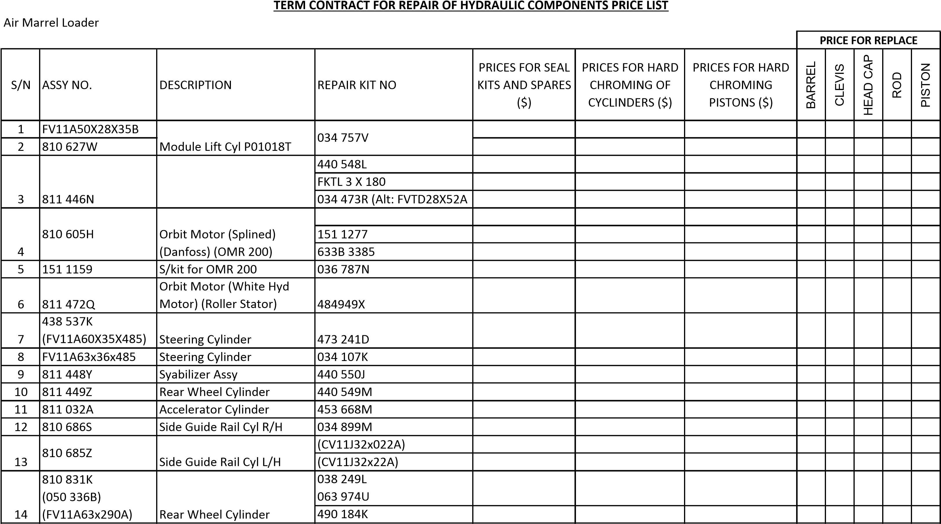
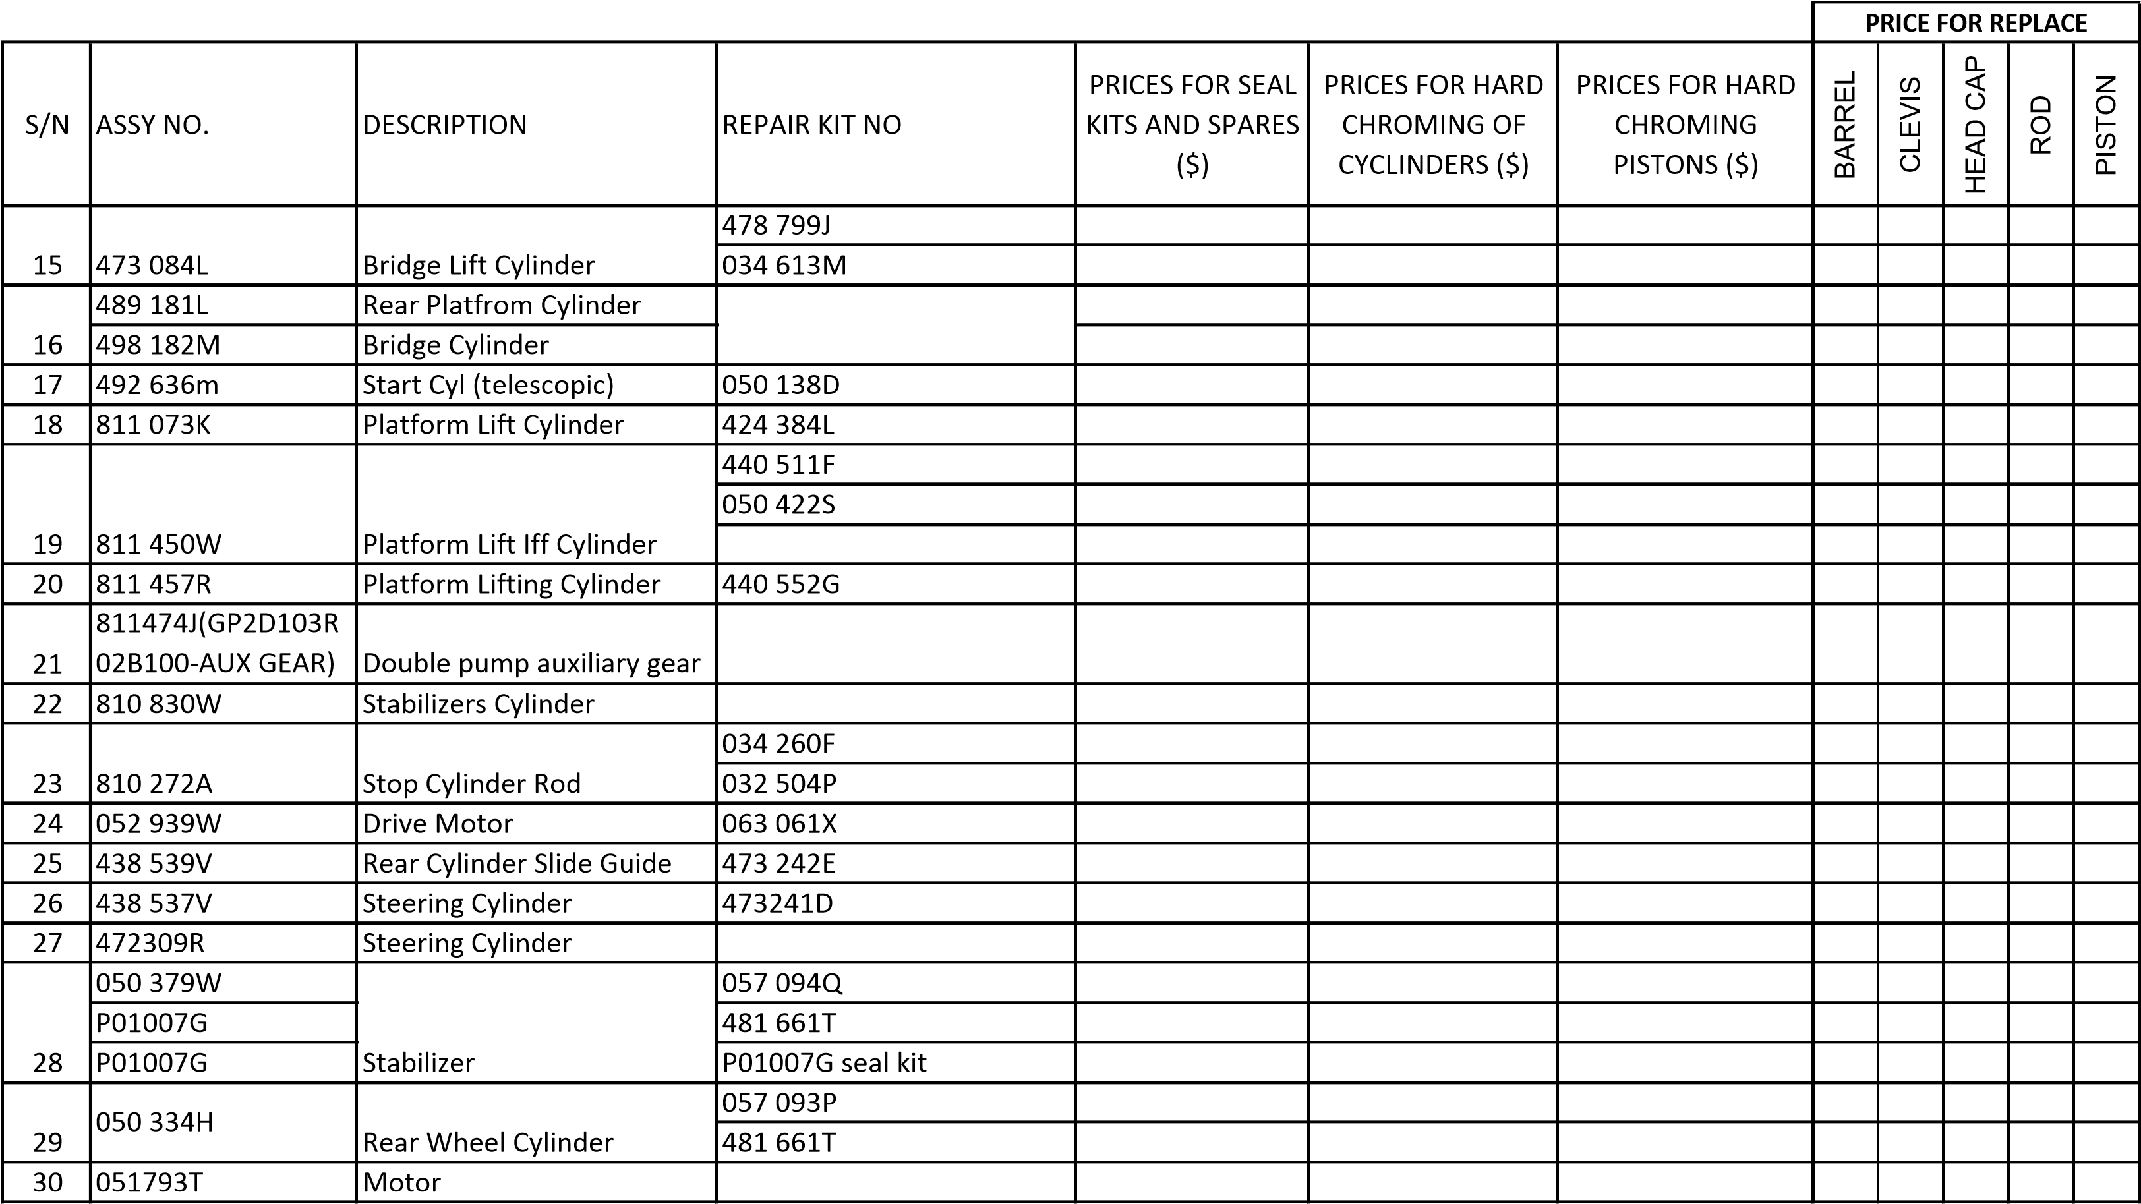
S/N
ASSY NO.
DESCRIPTION
REPAIR KIT NO
PRICES FOR SEAL
KITS AND SPARES
(
$)
PRICES FOR HARD
CHROMING OF
CYCLINDERS ($)
PRICES FOR HARD
CHROMING
PISTONS ($)
BARREL
CLEVIS
HEAD CAP
ROD
PISTON
PRICE FOR REPLACE
31
484 479
Y
Collapsible Cutaway Lifting
Cylinder
057 095
R
32
052939W/00
Hydraulic motor
33
P01018T
Cylinder module
34
H
810605
Motor
35

T
051796
)
ALT:811473R
(
Hydraulic motor
0570966
J

FMC COMMANDER
 |  |  |  |  |  |  | PRICE FOR REPLACE
S/N | ASSY NO. | DESCRIPTION | REPAIR KIT NO | PRICES FOR SEAL  KITS AND SPARES  ($) | PRICES FOR HARD  CHROMING OF  CYCLINDERS ($) | PRICES FOR HARD  CHROMING  PISTONS ($) | BARREL | CLEVIS | HEAD CAP | ROD | PISTON
1 | 621 5626 | Operator platform ex cyl | 621 5636 090
 | 620 0104 |  | 620 0104 090
2 | 621 5640 | Front Stabilizer cyl | 621 5640 090
 | 620 0736 |  | 620 0726 090
3 | 620 1571 | Bogy Wheel cyl | 620 1571 090
 | 621 5641 |  | 621 5641 090
4 | 620 4120 | Ausci Brake Single Rotor | 620 4120 090
 |  |  | 620 4120 003
 |  |  | 620 4120 004
 |  |  | 620 4120 006
5 | 620 0190 | Cyl 2nd Lift Sec Lift | 620 0190 090
 | 620 7663
 | 620 7911
 | 621 5645 |  | 621 5646 090
6 | 620 0188 | Pri Lift Cyl | 620 0188 090
 | 621 5644 |  | 621 5644 090
7 | 620 0183 | Strg Cyl Assy | 620 0183 090
8 | 621 5639 | Guide Cyl Assy | 621 5639 090
 |  |  | 620 0104 090
9 | 620 0188(long)  620 2103(short) | Folding Wing Cyl  (Cyl Guide Fwd) | 620 7041 090  620 2103 090
 | 621 5637 |  | 621 5637 090
 | 621 5643 |  | 621 5643 090
10 | 620 0236 | Bridge Lift Cyl | 620 0236 090
 | 621 5646 |  | 621 5646 090

 |  |  |  |  |  |  | PRICE FOR REPLACE
S/N | ASSY NO. | DESCRIPTION | REPAIR KIT NO | PRICES FOR SEAL  KITS AND SPARES  ($) | PRICES FOR HARD  CHROMING OF  CYCLINDERS ($) | PRICES FOR HARD  CHROMING  PISTONS ($) | BARREL | CLEVIS | HEAD CAP | ROD | PISTON
11 | U5MW0189 | Water Pump Assy
12 | 620 0141 | Hydraulic motor | 620 0141 090
 | 621 0141 | Hydraulic motor | 420700 (620 0141 901)
 | 622 0141 | Hydraulic motor | 435282 (620 0141 903)
 | 623 0141 | Hydraulic motor | 473914 (620 0141 902)
 | 624 0141 | Hydraulic motor | 419627 (620 0141 900)
13 | 621 5638 | Stabilizer Cyl
14 | 623 0244 | Platform Lift Cyl | 621 57 69 090
15 | 620 1428 | Hydraulic motor (orbit) | 620 1428 090  (alt SK0000 90)
 |  |  | 620 1428 00B
 |  |  | 620 1428 00C
 |  |  | 620 1428 003
16 | 620 4093 | Steering Valve  (Steering Motor) | 150 N 4031
17 | 515 8903 100 | Steering cyl | 515 8903 100 090
18 | 239 6667 093 | Brake Master Cyl | 239 6667 094
19 | 232 7267 1 | Control Unit | 232 7267 090
20 | 620 7030 | Rear Stab cyl | 620 0104 090
21 | 238 5452 | Module Lift Cyl | 232 7178 090
 |  |  | KWFC 150351
 |  |  | V97545
22 | 519 9548 | Bridge Lift Cyl (MDL)
23 | 620 0307 | Cylinder guide forward
24 | 621 5623 | MDL Stab Cyl | 621 5623 090

 |  |  |  |  |  |  | PRICE FOR REPLACE
S/N | ASSY NO. | DESCRIPTION | REPAIR KIT NO | PRICES FOR SEAL  KITS AND SPARES  ($) | PRICES FOR HARD  CHROMING OF  CYCLINDERS ($) | PRICES FOR HARD  CHROMING  PISTONS ($) | BARREL | CLEVIS | HEAD CAP | ROD | PISTON
25 | 621 5624 | MDL Stab Cyl Centre | 621 5624 090
26 | 515 7842 | Rear Assist Cyl | 615 7642 090
 |  | Bridge Lift Cyl | 519 9548 090
27 | 472309R | Steering valve | 150 4206 (thin)
 |  | Danfoss | 150N 4040 (thick)

PAX-STEP
 |  |  |  |  |  |  | PRICE FOR REPLACE
S/NO. | ASSY NO. | DESCRIPTION | REPAIR KIT NO | PRICES FOR SEAL  KITS AND SPARES  ($) | PRICES FOR HARD  CHROMING OF  CYCLINDERS ($) | PRICES FOR HARD  CHROMING  PISTONS ($) | BARREL | CLEVIS | HEAD CAP | ROD | PISTON
1 | B440100901 | Main Hoist Cyl Assy | 194001691  (alt:B441501900)
2 | B440200301R | Stabilizer right
3 | B440200301 | Stabilizer left
4 | P16-100C-2S6 | Hyd pump
5 | PX42S 21 HS | Stabilizer
6 | PX42S 21 HS LEFT | Stabilizer
7 | PX42S 22 HS LEFT | Tilit Cylinder
8 | PX42S 23 HS CYL | Cylinder swing step
9 | E300110200 | Main Hoist Cyl Assy
10 | E300120300 | Stabilizer front
11 | E300120310 | Stabilizer rear
12 | B440101001 | Slope Cyl Assy | B441501300
 |  |  | or B4415020

RECOVERY TRUCK
 |  |  |  |  |  |  |  | PRICE FOR REPLACE
S/N | ASSY NO. | DESCRIPTION | REPAIR KIT NO | PRICES FOR SEAL KITS AND SPARES ($) | PRICES FOR HARD  CHROMING OF  CYCLINDERS ($) | PRICES FOR HARD  CHROMING PISTONS  ($) | BARREL | CLEVIS | HEAD CAP | ROD | PISTON
1 | 2537 - 04 | Recovery Truck Cyl Main Boom | 257 04 04

ABL HI-LIFT & BUS
 |  |  |  |  |  |  |  | PRICE FOR REPLACE
S/NO. | ASSY NO. | DESCRIPTION | REPAIR KIT NO | PRICES FOR SEAL KITS AND SPARES ($) | PRICES FOR HARD  CHROMING OF  CYCLINDERS ($) | PRICES FOR HARD  CHROMING PISTONS  ($) | BARREL | CLEVIS | HEAD CAP | ROD | PISTON
1 | B440210101 | Stabilizer cylinder
2 | 6-02/10-51 | Cylinder door
3 | B440210301 | Stabilizer

CT1807F018
Appendix C (Annex A)
Page 10 of 15

FORKLIFT
 |  |  |  |  |  |  |  | PRICE FOR REPLACE
S/NO. | ASSY NO. | DESCRIPTION | REPAIR KIT NO | PRICES FOR SEAL KITS AND SPARES ($) | PRICES FOR HARD  CHROMING OF  CYCLINDERS ($) | PRICES FOR HARD  CHROMING PISTONS  ($) | BARREL | CLEVIS | HEAD CAP | ROD | PISTON
1 | Steering Cyl | (STFL-1) Cyl pistion rod | D510026
 |  | Cyl R/kit | D144355
________________
Company Stamp

HI-LIFT
 |  |  |  |  |  |  | PRICE FOR REPLACE
S/NO. | ASSY NO. | DESCRIPTION | REPAIR KIT NO | PRICES FOR  SEAL KITS AND  SPARES ($) | PRICES FOR  HARD  CHROMING OF  CYCLINDERS ($) | PRICES FOR HARD  CHROMING  PISTONS ($) | BARREL | CLEVIS | HEAD CAP | ROD | PISTON
1 | H32 BBR 21  H32 BBR 11  (H31 BBR 11)  (H31 BBR 21) | PTO Combination {  {  Shaft{ { | SKH 31
 |  |  | 27267
 |  |  | 27346
 |  |  | 27346-31
 |  |  | 27346A
 |  | Friction disc (8pcs) | 55501
 |  | Friction plate(7pcs) | 55502
 |  | bearing | 6027
2 | 271 MBAJ D3XR  271 MBAJ D5XR | PTO Combination (Chealsea) | SKC 271
 |  |  | SP703
 |  |  | 55501
 |  |  | 55502
3 | CS65-U6004-J1DP  To check housing before ordering | PTO Combination  (HL10,HL08) | PC-GSK-13
 |  |  | 06T35549
 |  |  | 49T33564
 |  |  | 49T33563
 |  |  | 49T35547
 |  |  | 10T35553
 |  |  | 10T28908
4 | (CS6S U6004 J1KP) |  | CS6 - GSK
 |  |  | 49T33564
 |  |  | 49T33563
 |  |  | 21T36511

 |  |  |  |  |  |  | PRICE FOR REPLACE
S/NO. | ASSY NO. | DESCRIPTION | REPAIR KIT NO | PRICES FOR  SEAL KITS AND  SPARES ($) | PRICES FOR  HARD  CHROMING OF  CYCLINDERS ($) | PRICES FOR HARD  CHROMING  PISTONS ($) | BARREL | CLEVIS | HEAD CAP | ROD | PISTON
5 | CFS 12 | PTO Pump  (for P/S also) | SK003
 |  |  | 26227 - 12
6 | P16 -100C -2S6 P16 - 115C -2S7 P16 - 150C - 2S7 | PTO PUMP  (Tyrone) | 18419 (alt 15419, B4210004, B421000401SK
 |  |  | 33433 (ALT 2869)
 |  |  | 33434
 |  |  | 27163
7 | 1940034/1  B440101301  B440100601 | Ext. Plat Cylinder  Side shift Cylinder
8 | B440100401 | Canopy Cylinder | B4415001
9 | 1 48250 2440 | Chamber Parking Brake Assy | 1 48252052 0
10 | B440100301 | Cyl main hoist left
11 | B440100701 | CYl main hoist right
12 | WHCT 9955 27HS | Canopy Cylinder Assy | Seal kit
 |  |  | Swivel Bearing
13 | 1 48100 601 0  148100 611 1 | Brake Valve Assy | 1 85576 053 0
14 | B440 200 101 | Stabilizer Assy | B441 504 300

 |  |  |  |  |  |  | PRICE FOR REPLACE
S/NO. | ASSY NO. | DESCRIPTION | REPAIR KIT NO | PRICES FOR  SEAL KITS AND  SPARES ($) | PRICES FOR  HARD  CHROMING OF  CYCLINDERS ($) | PRICES FOR HARD  CHROMING  PISTONS ($) | BARREL | CLEVIS | HEAD CAP | ROD | PISTON
15 | WHCT 9956 26HS  WHCT 9955 27HS | Shift Shift BXT Cylinder  Canopy | }WHCT 995 26 HS }
16 | WHCT9955 24HS | Scissor cyl (main hst)
17 | WHCT9955 25HS | Stabilizer Assy
18 | 701 7878 | Stabilizer Jack | 704 3212
19 | 702 8868 | Canopy Cyl | 440 - 10137
20 | 702 8879 | Cylinder plaform side shift
21 | B440200201 | Stabilizer assy
22 | B440200101 | Stabilizer assy
23 | C300110010 | Main cylinder
24 | C300110110 | Main cylinder
25 | FC24FURY | Main cylinder
26 | HCX47/04/091 | Stabilizer Assy
27 | M300100410 | Stabilizer right
28 | M300100310 | Stabilizer left
29 | 701 7786 | Main Hoist Cylinder | 440 - 10677

CT1807F018
Appendix C (Annex A)
Page 14 of 15

Transporter
 |  |  |  |  |  |  |  | PRICE FOR REPLACE
S/NO. | ASSY NO. | DESCRIPTION | REPAIR KIT NO | PRICES FOR SEAL KITS AND SPARES ($) | PRICES FOR HARD  CHROMING OF  CYCLINDERS ($) | PRICES FOR HARD  CHROMING PISTONS  ($) | BARREL | CLEVIS | HEAD CAP | ROD | PISTON
1 | 064055 | Hyd Motor (Linde) | 0111 798
 |  |  | 0111 799
 |  |  | 0111 896
 |  |  | 0111 003
 |  |  | 32207 Q
 |  |  | 293 324 02 02
2 | 840 CIL 0005 | Strg Cyl | 062 014
3 | 840CIL0101 | cylinder height
4 | 063 239  (Danfoss) | Steering Valve Assy  (motor) | 150 N 4040
5 | 903109C | cylinder height | 062 973
6 | 5833 415 | stg motor | 150 N 4040
7 | 151 0717 | hyd motor | 151 1286
8 | 061533 | Steering Valve Assy  (motor) | 010-817
9 | 620-1428 | Orbit Motor | 620-1428-090
________________
Company Stamp
CT1807F018

Appendix C (Annex A)
Page 15 of 15
Other: |  |  |  |  |  |  |  | PRICE FOR REPLACE
S/N | P/N | DESCRIPTION | REPAIR KIT NO | PRICES FOR SEAL  KITS AND SPARES  ($) | PRICES FOR HARD  CHROMING OF  CYCLINDERS ($) | PRICES FOR HARD  CHROMING  PISTONS ($) | BARREL | CLEVIS | HEAD CAP | ROD | PISTON
1 | 627-7022 | Pump
2 | 670024 | Steering Cylinder
3 | 82979 | Steering Motor
4 | 85354 | Steering Cylinder
5 | 86145 | Cylinder
6 | 106650 | Steering Cylinder
7 | 25320286R001 | Ram Cyl
8 | 300100620 | Push up Cylinder
9 | 300100610 | Main Cylinder
10 | 300100611 | Main Cylinder
11 | 300100840 | Stab Cylinder
12 | M300100810 | Platform Cylinder
13 | M300100701 | Stabilizer Cylinder
14 | A01052F | Cylinder
15 | A01092Y | Steering Cylinder
16 | A02032H | Pistion pump
17 | A02110V | Hydrauluc pump
18 | A02110F | Pistion pump
19 | A03095Z | Steering Unit
20 | P01003C | Lift off Cylinder
21 | PO1008H | Stabilizer Cylinder
22 | P01012M | Steering Cylinder
23 | PO1045V | Rear Wheel Cylinder
24 | PO1055J | Platform Cylinder
25 | P01056K | Platform Take-off Cylinder
26 | 25320343ROO | Stabilizer Cylinder
________________
Company Stamp

